LMS BUGS
- when new user retgister at 1st the topic and section are not enable
- restriction on admin to add/delete the course user just view the
- completed course flash card colour option on admin side for course
- created the notice board and show on student hide account/finance
- in add role add course and 4 option in management of add role hide job board in student side

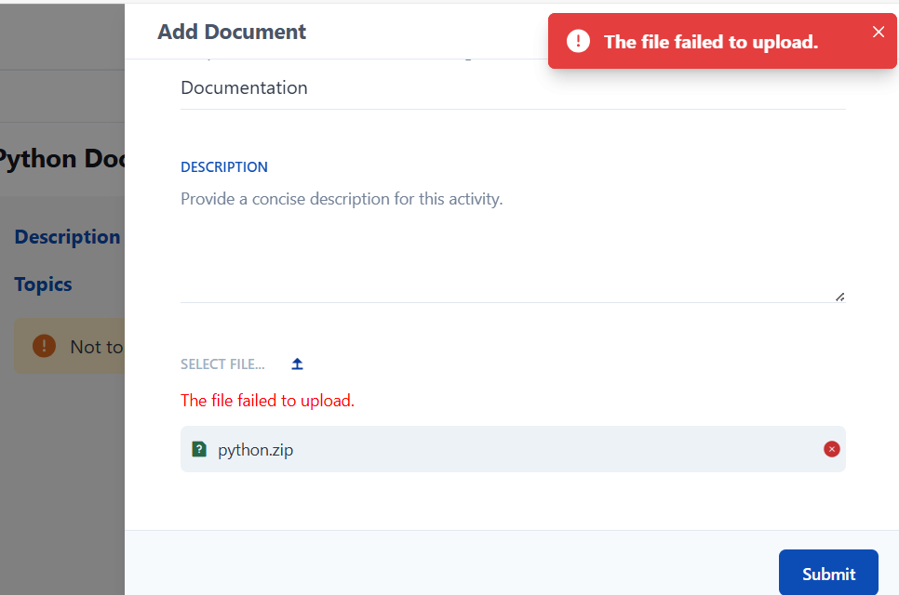
Mention doc type

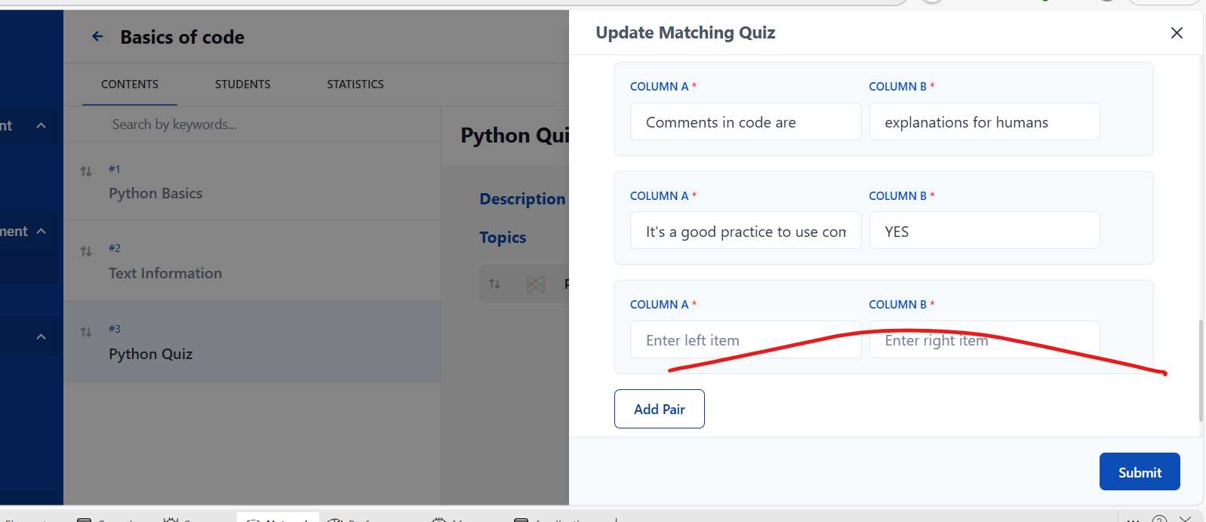
Add option to remove

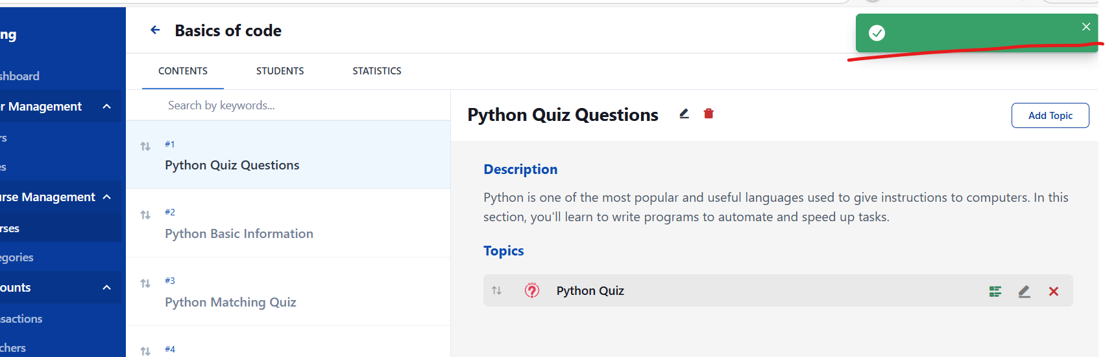
After updating the name of section
And section shuffle is not working.

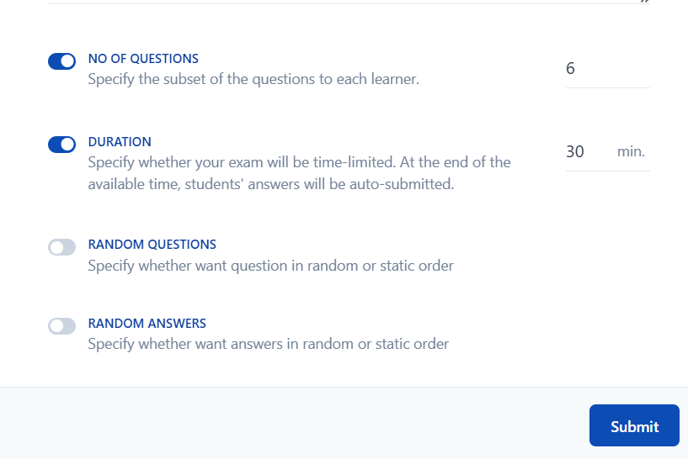
Apply backend functionality for these.

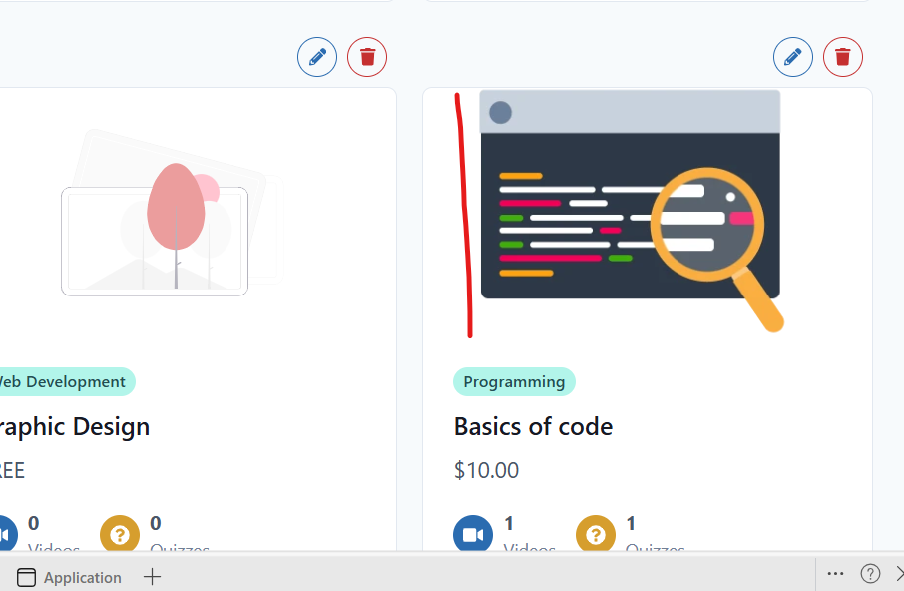
Place image at the centre of the screen

